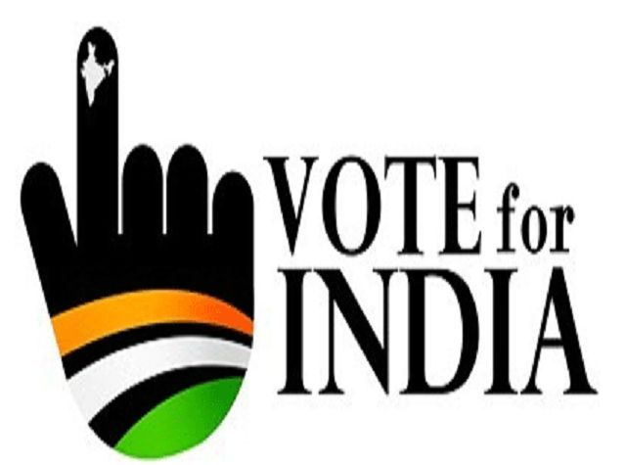
4. Electoral Politics
Introduction:
- In democracy, it is neither possible nor necessary for people to govern directly.
- Democracy in real sense is people are governed by representatives.
- The system of electing the representatives is known as ‘Election’.
- In this chapter, we are going to understand –
- The meaning of election
- Why election is necessary?
- What is Election system in India.
- Electoral competition among political parties.
- Democratic election.
- What makes election in India Democratic?
What do you mean by Election?
Definition- “The mechanism or procedure by which people choose their representatives at regular intervals is called election.”
Why do we need Election?
Let us imagine a democracy without election and discuss the following points in these situations-
- Can large community sit together everyday and take decisions?
- Do you think all people have time and knowledge to take decision on all matters?
- Is there a democratic way of selecting representatives without election?
- Can you think of a place where people are chosen on the basis of age, experience, education or knowledge?
- How will you decide who is having more experienced or knowledge one?
- The above mentioned questions lead you to believe that there is essentially requirement of conducting election in every democratic countries.
Why do we need election?
The elections are needed for any representative democracy because-
- People make assessment on the basis of education, knowledge or experience.
- Through election only we can analyze whether people like their representatives or not.
- We ensure that representative rulers work according to the wishes of the people or not.
- People decide which representative will continue or which one will not continue.
In an election , the voters have many choices:
- They can choose who will make laws for them.
- They can choose who will form the government and take major decisions.
- They can choose the party whose policies will guide the Government and law making.
What makes an election Democratic?
- Election can be held in many ways.
- All, democratic and non- democratic countries have some kind of election.
- We have already discussed in detail, in the previous chapter about it.
- We know that what are the differences between democratic election and non- democratic election.
- Let us recall a simple list of the minimum conditions of a democratic election:
- Everyone should be able to choose i.e. everyone should have one vote and every vote should have equal value.
- There should be something to choose from. Parties and candidates should be free to contest election and should offer some real choice to the voters.
- The choice should be offered at regular intervals.
- The candidate preferred by the people should get elected.
- Election should be conducted in a free and fair manner where people can choose as they really wish.
Types of Elections:
- General Election-
The Lok Sabha and the Vidhan Sabha in the states are normally elected every five years which is known as General Election.
- By –Election-
Fresh elections are held in the constituencies if a representative from a constituency dies while in office, is called as By- Election.
- Mid-Term Election-
If the Lok Sabha or any of the state Assembly is dissolved before expiry of its term and elections are held, it is called as Mid- Term election.
Conclusions-
- These minimum conditions of a democratic election seems to be very simple and easy.
- But, there are many countries where these conditions are not fulfilled.
- We are going to analyze whether these conditions are fulfilled or not in our countries.
- Before we enter into the election procedure in India, let us think over the election and political competition.
Political Competition:
- Election in other words is all about political competition.
- It is a competition between the candidates to hold powers.
Is it Good to have political competition?
To understand it, let us go through the demerits and merits of political competition.
Demerits:
- It creates a sense of disunity and ‘factionalism’ (division) in every locality.
- Political parties level allegations against one another.
- Parties and candidates often use dirty tricks to win election.
- This pressure to win electoral fights does not allow sensible long-term policies to be formulated.
- Good people who wish to serve the nation may not like to enter in this arena.
Merits of political competition
Our constitutional makers were aware of these problems, yet chose to have free competition due to the following reasons-
- This system works better in the long run.
- All political leaders know what is good for the people and are motivated only by the desire to serve them.
- This works as an incentive to political parties and leaders.
- If they are able to satisfy the voters, then they will be chosen by the people.
- If a political party is motivated only by desire to be in power, even then it will be forced to serve the people.
- It reveals the real motive of political parties.
- It gives choices to voters to choose among the best.
Example-
It works like marketing system, a shopkeeper may be interested with his personal profit even then he has to provide good service to the consumers. If he does not, the customer will go to the other shop.

The Election Procedure in India

In our country we follow an area based system of representation.
- The country is divided into different areas for purposes of election.
- These areas are called electoral constituencies.
- The voters who live in an area elect one representative from that area.
- For the Lok Sabha elections, the country is divided into 543 constituencies.
There are currently 543 constituencies. The maximum size of the Lok Sabha as outlined in the Constitution of India is 550 members made up of up to 530 members representing people of the states of India and up to 20 members representing people from the Union Territories on the basis of their population.
- The representative elected from each constituency is called a Member of Parliament or an MP.
- Similarly, each state is divided into specific number of Assembly constituencies.
- The elected members, in this case are called as the Members of Legislative Assembly or an MLA.
- Each parliamentary has within it several assembly constituencies.
- The same principle applies for panchayat and Municipal elections.
- Each village or town is divided into several ‘wards’ that are like constituencies.

Some constituencies are reserved for people who belong to the Scheduled Castes (SC) and Scheduled Tribes (ST).
- In a SC reserved constituency only someone who belongs to the Scheduled Castes can stand for election.
- Similarly, only those who belong to the Scheduled Tribes can contest an election from a constituency reserved for ST.

Lok Sabha Constituencies
Total constituencies | 543
General | 423
Reserved (SC) | 79
Reserved (ST) | 41

In the 15th Lok Sabha Election, there was revised Reserved constituency;
- 84 seats are reserved for the SCs.
- 47 seats are reserved for the STs.
- This system of reservation was extended to other weaker sections at the districts and the local levels.
- In many states, seats in rural (panchayat) and urban (municipal and corporation) local bodies are now reserved for Other Backward Classes (OBC) as well.
- Similarly, one- third of the seats are reserved for women in urban and rural areas.

In a democratic election, the list of those who are eligible to vote is prepared much before the election given to everyone.
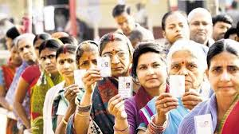
- This list is officially called as ‘Electoral Roll’ and is normally known as the voters’ List.
- It is responsibility of the government to see that all the eligible voters’ name put in the list.
- When new persons attain the required age, their names are included in the list.
- Names of those, who move out of the place or dead are deleted.
- In the last few years a new system of Election Photo Identity Card (EPIC) has been introduced.

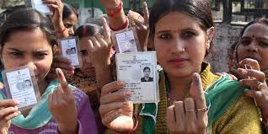

- But the card is not yet compulsory for voting.
- For voting, the voters can show many other proofs of identity like the ration card or the driving license.

Every person who wants to contest an election has to fill a ‘nomination form’ and give some money as ‘security deposits’.
- Supreme Court has given direction that every candidate has to make a legal declaration , giving full details under following –
- Serious criminal cases pending against the candidate.
- Details of the assets and liabilities of the candidates and his or her family.
- Educational qualifications of the candidate.
- This information has to be made public.
- It provides an opportunity to the voters to make their decision on the basis of the information.

No educational qualification is necessary or an important position to become an elected representative in India. Why?
- Educational qualifications are not relevant to all kinds of works. For example to become the member of Indian cricket team educational qualification is not a must.
- It is left to the people to decide how much importance they give to educational qualification.
- Putting educational qualification would go against the very spirit of democracy.

The main purpose of election is to give a chance to choose their representatives.
- Campaigns take place for a two- week period between the announcement of the final list of candidates and the date of polling.
-
- The candidates contact their voters, political leaders address election meetings and political parties mobilize their supporters.
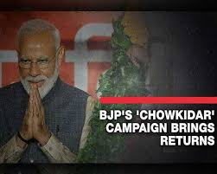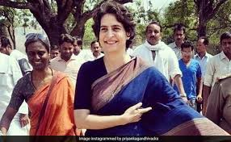

- Newspapers and television news are full of election related stories and debates.
- Political parties try to focus public attention on some big issues.
- They do this by the help of some attractive ‘slogans’.
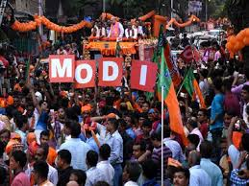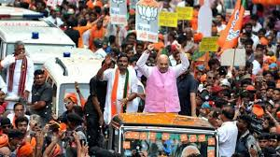
Some of the important slogans used by different political parties-
- The Congress party led by Indira Gandhi gave the slogan of “Garibi Hatao” in the Lok Sabha elections of 1971.
- “Save Democracy” was the slogan given by Janata party in the next Lok Sabha election held in 1977.
- The Left Front used the slogan of “Land to the Tillers” in the West Bengal Assembly election held in 1977.
- “Protect the Self-Respect of the Telugu” was the slogan of N.T. Rama Rao in the State Assembly election in 1983.
- To ensure a fair and equal chance to every political parties and the candidates, during the election campaign, election law is introduced.
- No party or candidate is allowed to-
- Bribe or threaten the voters;
- Appealing them in the name of caste or religion;
- Use government resources for election campaign;
- Spend more than Rs. 25 lakh in a constituency for a Lok Sabha and 10 lakhs in an Assembly election.
What will happen, if the political parties and candidates break the election law?
- Their election can be rejected by the court even after they have declared elected.
In addition to that, all the political parties in our country have agreed to a ‘Model Code of Conduct’ for election Campaigns.
According to this no party or candidate can:
- Use any place of worship for election propagation;
- Use Govt. Vehicles, aircrafts and officials for elections;
- Once elections are announced, Ministers shall not lay foundation stones of any projects, take any big policy decisions or make any promises of providing public facilities.

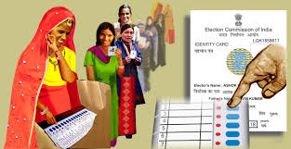Polling and counting of votes:
- The final stage of an election is the day when the voters cast or ‘poll’ their vote.
- Every person whose name is on the voters’ list can go to a nearby polling centre.
- Once the voter goes inside the booth, the election officials identify, put mark on the finger to cast his/her vote.
- An agent of each candidate is allowed to sit inside the polling booth centre.
- Earlier there was a ballot paper, with names of the contesting candidates along with party name and symbols were used.
- Nowadays, Electrical Voting Machines (EVM) are used.

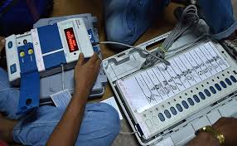
- Once the polling is over, all the EVMs are sealed and taken to a secure place.
- On a fixed date, all the EVMs from the constituencies are opened and the votes secured by the candidates are counted.
- The candidate who secures the highest number of votes from a constituency is declared elected.
- Usually, the counting of votes in all the constituencies take place at the same time.
- Television channels, radio and newspapers report this event.
- Form the next government.
What makes election in India Democratic?
- We get information about unfair practices in election.
- Newspapers and television reports often refer to such allegations.
- Many of these reports are correct.
- Does it defeat the very purpose of election?
With all negative points, limitations and unfair practices, we still hold the election in India as democratic because of the following three aspects –
- Independent Election Commission:
- In our country, elections are conducted by an independent and very powerful Election Commission.
- It enjoys independence like judiciary in India.
How can we say it is independent body?
- The Chief Election Commissioner is appointed by the president of India.
- Once appointed, the Chief Election Commissioner is not answerable to the president or the government.
- If ruling party or the government does not like what the commission does, even then it is very difficult to remove the CEC.
- Very few election commissions in the world have such wide-ranging powers as the Election Commission in India.
Powers of Election Commission:
- It takes decision on every aspects of conduct and control of election.
- It implements the Code of Conduct and punishes any candidate or party that violates it.
- Recognition to political parties.
- The Election Commission allots symbols to political parties.
- The Election Commission prepares the Electoral Rolls and includes names of valid voters in it.
- During the election period it can order even the government to follow some guidelines, to prevent use and misuse of power.
- Government officers on election duty, work under the control of the EC and not under the government.
- The election officials if they believe polling was not fair in some booths or entire constituency, they can order a re-poll.
B. Popular Participation:
People’s participation in election is usually measured by following ways-
- Voter Turnout- It indicates the percent of eligible voters who actually cast their vote.

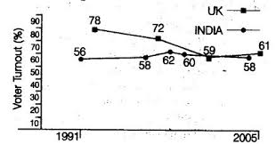
- Over the fifty years, the turnout in Europe and North America has declined.
- In India, the turnout has either remained stable or actually gone up.
- Involvement of social groups-
- In India, the poor, illiterate and underprivileged people vote in larger proportion as compared to rich and privileged classes.
- In USA, poor people and African Americans and Hispanics vote much less than the rich and the white people.
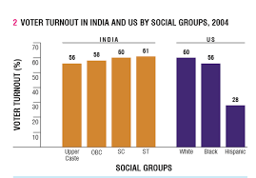
3. General views regarding election-
- Common people in India, attach a lot of importance to elections.
- They feel that through election they can pressurize government in their favour.
- They also feel that their vote matters in the way things are run in the country.
4. Participation in election related activity-
- The Indian voters’ interest in election related activities has been increased.
- During the past elections, more than one third voters took part in campaign- related activities.
- More than half of the people identified themselves as being close to one or other political party.
- One out of every seven voters is a member of a political party.
C. Acceptance of election outcomes-
The outcomes of India’s election speaks for itself-
- The ruling parties routinely lose elections in India both at the national and state level.
- In the US, an incumbent (sitting) elected representative rarely loses an election.
- In India about half of the sitting MPs and MLAs lose election.
- Candidates who are known to have spent a lot of money on ‘buying votes’ and those with known criminal connections often lose election.
- Except few disputed elections, the electoral outcomes are usually accepted as ‘people’s verdict’ by the defeated party.
Challenges to Free and Fair election:
1. Candidates and parties with a lots of money enjoy an unfair advantages over smaller parties independent candidates.
2. Some candidates with criminal records are able to secure tickets from major parties due to their political connection.
3. Some families tend to dominate political parties.
4. Election offer very little choice to ordinary people.
5. All the major parties are quite similar to each other in policies and practice.
6. Smaller parties and independent candidates suffer a huge disadvantages
Compared to bigger parties in terms of money power and organizational support.
7. Wide gap between the seat won and the votes polled. It means that the political parties do not secure as many per cent of seats as many percentage of votes they secure.
8. Elections have become very expensive in India. A poor person however capable , he may not be able to dream of contesting an election.
9. There is misuse of Government machinery during the election.
10. It is often seen that the political parties instigate the feelings of people by propagating on the basis of religion, caste, language, race etc.

Eercises:
A. Very short answer type questions-
1. Define the following-
- Election
Ans. “The mechanism or procedure by which people choose their representatives at regular intervals is called election.”
- Constituency
Ans. Voters in a geographical area elect a representative to the legislative bodies is known as a constituency.
- Electoral Roll or Voters’ List
Ans. In a democratic election, the list of people eligible to vote is prepared much before the election is officially called the Electoral Role or Voter’s List.
- Model Code of Conduct
Ans. A set of norms and guidelines to be followed by political parties and contesting candidates during election time.
- Voter Turnout
Ans. The percentage of eligible voters who caste their votes in an election.
- Incumbent
Ans. The current holder of a political office.
- Rigging
Ans. Fraud and malpractices indulged by a party or candidate to increase its votes.
- Universal Adult Franchise
Ans. Every Indian citizen of 18 years and above has the right to vote irrespective of caste, creed and sex.
- Election Manifesto
Ans. A document published by each political party before election containing the policies and programmes of the party.
- By- Election
Ans.
By –Election- Fresh elections are held in the constituencies if a representative from a constituency dies while in office, is called as By- Election.
2. What is General Election?
Ans. The Lok Sabha and the Vidhan Sabha in the states are normally elected every five years which is known as General Election.
- What is number of Constituency in Lok Sabha at present?
Ans. For the Lok Sabha elections, the country is divided into 543 constituencies.

- How many seats are reserved for scheduled Caste and scheduled Tribe at present after 15th Lok Sabha Election?
Ans.
In the 15th Lok Sabha Election, there was revised Reserved constituency;
- 84 seats are reserved for the SCs.
- 47 seats are reserved for the STs.
- Who appoints the Chief Election Commissioner in India?
Ans. The President appoints the Chief Election Commissioner in India.
- What was known as ‘Nyaya Yudh’?
Ans. A movement led by Chaudhary Davi Lal against the Congress in Haryana in 1982.
7. What was the name of political party in Haryana in 1982?
Ans. Lok Dal.
8. Who is the present Chief Election Commissioner of India?
Ans. Mr. Sunil Arora.
9. What was ballot paper?
Ans. A ballot paper was a sheet of paper
On which the names of the contesting candidates along with party name and symbols are listed.
10. How, people’s participation in election is usually measured ?
Ans. By voters’ Turnout.
B. Short answer type questions-
- What major choices are generally made by the people?
Ans.
In an election , the voters have many choices:
- They can choose who will make laws for them.
- They can choose who will form the government and take major decisions.
- They can choose the party whose policies will guide the Government and law making.
- Give three reasons, why people are ruled by their representatives?
Ans. There are more than one hundred countries in the world in which election take place to choose people’s representatives due to the following reasons-
1. A rule of the people is not possible in a large community.
2. All the people cannot sit together every day and take all the decisions.
3. Nor it is possible for everyone to have the time and knowledge to take decisions on all matters.
3. Mention the major demerits of electoral competitions.
Ans. Demerits:
- It creates a sense of disunity and ‘factionalism’ (division) in every locality.
- Political parties level allegations against one another.
- Parties and candidates often use dirty tricks to win election.
- This pressure to win electoral fights does not allow sensible long-term policies to be formulated.
- Good people who wish to serve the nation may not like to enter in this arena.
4.“Our constitution makers were aware of the demerits of electoral competition, but opted for free competition.” Why? Give three reasons.
Ans. Our constitutional makers were aware of these problems, yet chose to have free competition due to the following reasons-
- This system works better in the long run.
- All political leaders know what is good for the people and are motivated only by the desire to serve them.
- This works as an incentive to political parties and leaders.
- If they are able to satisfy the voters, then they will be chosen by the people.
- If a political party is motivated only by desire to be in power, even then it will be forced to serve the people.
- It reveals the real motive of political parties.
- It gives choices to voters to choose among the best.
5. Which three legal declaration is to be made by every candidate while filling a Nomination Paper?
Ans. Supreme Court has given direction that every candidate has to make a legal declaration , giving full details under following –
1. Serious criminal cases pending against the candidate.
2. Details of the assets and liabilities of the candidates and his or her family.
3. Educational qualifications of the candidate.
6. Why is there no educational qualification needed for any candidate?
Ans. No educational qualification is necessary or an important position to become an elected representative in India because-
- Educational qualifications are not relevant to all kinds of works. For example to become the member of Indian cricket team educational qualification is not a must.
- It is left to the people to decide how much importance they give to educational qualification.
- Putting educational qualification would go against the very spirit of democracy.
7. Make the list of important slogans made by different political parties.
Ans. Some of the important slogans used by different political parties-
- The Congress party led by Indira Gandhi gave the slogan of “Garibi Hatao” in the Lok Sabha elections of 1971.
- “Save Democracy” was the slogan given by Janata party in the next Lok Sabha election held in 1977.
- The Left Front used the slogan of “Land to the Tillers” in the West Bengal Assembly election held in 1977.
- “Protect the Self-Respect of the Telugu” was the slogan of N.T. Rama Rao in the State Assembly election in 1983.
8. Mention the election laws that every party or candidate has to follow during election campaign.
Ans. To ensure a fair and equal chance to every political parties and the candidates, during the election campaign, election law is introduced.
No party or candidate is allowed to-
1. Bribe or threaten the voters;
2. Appealing them in the name of caste or religion;
3. Use government resources for election campaign;
4. Spend more than Rs. 25 lakh in a constituency for a Lok Sabha and 10 lakhs in an Assembly election.
9. Mention the Model Code of Conduct that all parties in our country have agreed to follow during election campaign.
Ans. In addition to the Election Laws, all the political parties in our country have agreed to a ‘Model Code of Conduct’ for election Campaigns.
According to this no party or candidate can:
- Use any place of worship for election propagation;
- Use Govt. Vehicles, aircrafts and officials for elections;
- Once elections are announced, Ministers shall not lay foundation stones of any projects, take any big policy decisions or make any promises of providing public facilities.
10. How can we state that there is an Independent Election Commission in India?
Ans.
- The Chief Election Commissioner is appointed by the president of India.
- Once appointed, the Chief Election Commissioner is not answerable to the president or the government.
- If ruling party or the government does not like what the commission does, even then it is very difficult to remove the CEC.
- Very few election commissions in the world have such wide-ranging powers as the Election Commission in India.

C. Long Answer type question-
1. What makes Election in India Democratic?
Ans. we hold that the election in India is democratic because of the following three aspects –
A. Independent Election Commission:
- In our country, elections are conducted by an independent and very powerful Election Commission.
- It enjoys independence like judiciary in India.
- The Chief Election Commissioner is appointed by the president of India.
- Once appointed, the Chief Election Commissioner is not answerable to the president or the government.
- If ruling party or the government does not like what the commission does, even then it is very difficult to remove the CEC.
B. Popular Participation:
People’s participation in election is usually measured by following ways-
- Voter Turnout- It indicates the percent of eligible voters who actually cast their vote.
- Over the fifty years, the turnout in Europe and North America has declined.
- In India, the turnout has either remained stable or actually gone up.
- Involvement of social groups-
- In India, the poor, illiterate and underprivileged people vote in larger proportion as compared to rich and privileged classes.
- In USA, poor people and African Americans and Hispanics vote much less than the rich and the white people.

- General views regarding election-
- Common people in India, attach a lot of importance to elections.
- They feel that through election they can pressurize government in their favour.
- They also feel that their vote matters in the way things are run in the country.
- Participation in election related activity-
- The Indian voters’ interest in election related activities has been increased.
- During the past elections, more than one third voters took part in campaign- related activities.
- More than half of the people identified themselves as being close to one or other political party.
- One out of every seven voters is a member of a political party.
C. Acceptance of election outcomes-
The outcomes of India’s election speaks for itself-
- The ruling parties routinely lose elections in India both at the national and state level.
- In the US, an incumbent (sitting) elected representative rarely loses an election.
- In India about half of the sitting MPs and MLAs lose election.
- Candidates who are known to have spent a lot of money on ‘buying votes’ and those with known criminal connections often lose election.
- Except few disputed elections, the electoral outcomes are usually accepted as ‘people’s verdict’ by the defeated party.
2. Explain the power and functions of Election Commission.
Ans. Powers of Election Commission:
- It takes decision on every aspects of conduct and control of election.
- It implements the Code of Conduct and punishes any candidate or party that violates it.
- Recognition to political parties.
- The Election Commission allots symbols to political parties.
- The Election Commission prepares the Electoral Rolls and includes names of valid voters in it.
- During the election period it can order even the government to follow some guidelines, to prevent use and misuse of power.
- Government officers on election duty, work under the control of the EC and not under the government.
- The election officials if they believe polling was not fair in some booths or entire constituency, they can order a re-poll.
3. Provide four arguments to describe the popular participation in India.
Ans. . Popular Participation:
People’s participation in election is usually measured by following ways-
- Voter Turnout- It indicates the percent of eligible voters who actually cast their vote.
- Over the fifty years, the turnout in Europe and North America has declined.
- In India, the turnout has either remained stable or actually gone up.
- Involvement of social groups-
- In India, the poor, illiterate and underprivileged people vote in larger proportion as compared to rich and privileged classes.
- In USA, poor people and African Americans and Hispanics vote much less than the rich and the white people.

- General views regarding election-
- Common people in India, attach a lot of importance to elections.
- They feel that through election they can pressurize government in their favour.
- They also feel that their vote matters in the way things are run in the country.
- Participation in election related activity-
- The Indian voters’ interest in election related activities has been increased.
- During the past elections, more than one third voters took part in campaign- related activities.
- More than half of the people identified themselves as being close to one or other political party.
- One out of every seven voters is a member of a political party.
4. What does the outcomes of India’s election speaks for itself?
Ans. The outcomes of India’s election speaks for itself-
- The ruling parties routinely lose elections in India both at the national and state level.
- In the US, an incumbent (sitting) elected representative rarely loses an election.
- In India about half of the sitting MPs and MLAs lose election.
- Candidates who are known to have spent a lot of money on ‘buying votes’ and those with known criminal connections often lose election.
- Except few disputed elections, the electoral outcomes are usually accepted as ‘people’s verdict’ by the defeated party.
5. Which major challenges are faced for free and fair elections in India? Explain in detail.
Ans. Challenges to Free and Fair election:
1. Candidates and parties with a lots of money enjoy an unfair advantages over smaller parties independent candidates.
2. Some candidates with criminal records are able to secure tickets from major parties due to their political connection.
3. Some families tend to dominate political parties.
4. Election offer very little choice to ordinary people.
5. All the major parties are quite similar to each other in policies and practice.
6. Smaller parties and independent candidates suffer a huge disadvantages
Compared to bigger parties in terms of money power and organizational support.
7. Wide gap between the seat won and the votes polled. It means that the political parties do not secure as many per cent of seats as many percentage of votes they secure.
8. Elections have become very expensive in India. A poor person however capable , he may not be able to dream of contesting an election.
9. There is misuse of Government machinery during the election.
10. It is often seen that the political parties instigate the feelings of people by propagating on the basis of religion, caste, language, race etc.

